**Name : Mayur Gunjal**

**Roll no :021330024531**

**3 Success Stories of Digital Transformation Companies**

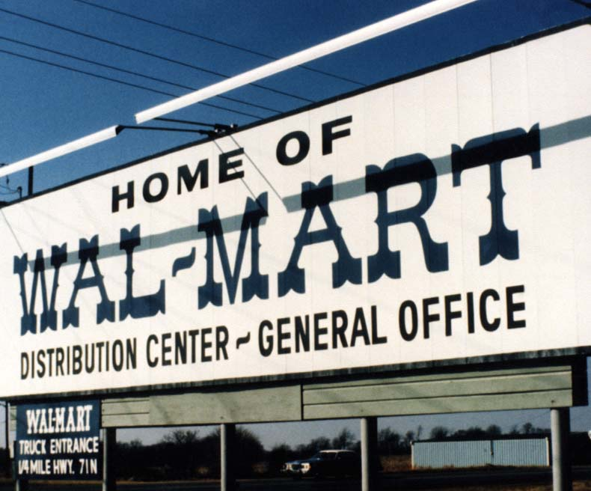**Walmart**

1. **What technology is used?**

* Walmart Pay: This mobile payment system lets customers use their smartphones to pay
* Store No. 8: Walmart has a tech incubator! It's all about fun stuff like VR shopping and drone delivery.
* Walmart Labs: Here, they’re working on AI & machine learning to make shopping better and help out with the supply chain.
* Online Marketplace: A strong e-commerce platform that welcomes third-party sellers.
* Grocery Pickup & Delivery: You can order groceries online for pickup or home delivery. They use smart logistics to make it easy.

1. **Before & after story**

**Before Digital Transformation**

* Customer Interaction & Ordering: Most shopping happened in stores, with not much online stuff. People had to visit the stores to see what's available and buy things.
* Operational Efficiency: They managed inventory by hand and didn’t use data much, which made stocking a bit messy.
* Marketing & Customer Engagement: Regular ads like print and TV worked back then, but there wasn’t much direct chat with customers.
* Delivery & Logistics: The supply chain was kind of old-fashioned. There wasn’t really an online order system.

**After Digital Transformation**

* Customer Interaction & Ordering: Now there’s a smooth experience! Customers can shop online a lot, plus they can use the app too.
* Operational Efficiency: With AI help, inventory management is automated! This means stocking is a lot better & waste is down.
* Marketing & Customer Engagement: They use cool digital marketing tricks now—think personalized ads on social media and email campaigns to engage customers better!
* Delivery & Logistics: Logistics got advanced! They have real-time tracking for grocery orders, plus they manage warehouses super well.

1. **What strategies did they use?**

* Mobile Payment System: Walmart Pay got launched to make checking out simple and works well with the Walmart app for a fun shopping experience.
* E-commerce Expansion: They put a lot of money into their online marketplace to compete with big names like Amazon, offering tons of products.
* AI & Machine Learning: AI helps them manage inventory and predict what people might want, which keeps the supply chain running smoothly!
* Omnichannel Strategy: A united shopping experience now combines online and store visits. This includes grocery pickup services too.
* Tech Incubators: Store No. 8 & Walmart Labs were set up to spark innovation using neat tech like VR & drones!

1. **Challenges they faced**

* Legacy Systems: Updating old IT systems so they match newer digital tools was tough.
* Competition: There’s such fierce competition from other e-commerce companies that keeping up required ongoing innovation & lots of investment!
* Logistics Optimization: Making sure everything works smoothly across channels was super complicated and needed many resources.
* Data Privacy: They had to be careful managing lots of customer info while following data protection rules—very important!
* Employee Training: Teaching staff how to use new tools was quite an undertaking but really necessary.

1. **Why are businesses going digital?**

Walmart wants to go digital to stay ahead in retail, give customers great experiences, & make things run smoother overall. By jumping into digital tools, they’re creating a fantastic omnichannel shopping experience, improving inventory systems, & boosting supply chain efficiency too! This change helps them meet the needs of tech-savvy shoppers while keeping their top position in the market.

**Microsoft**

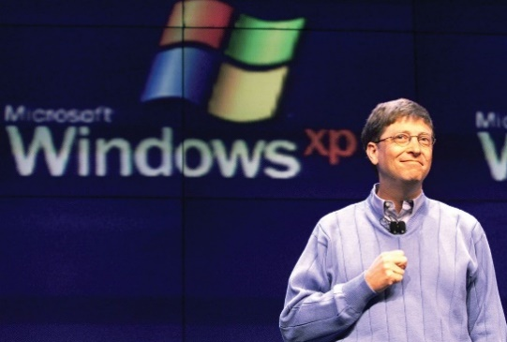

1. **Which technology is used?**

•Azure: This is cloud platform. It offers cool stuff like AI, machine learning, & IoT.

•Office 365: A helpful set of tools. It brings cloud functions together for productivity.

•LinkedIn: A networking platform for professionals. It boosts Microsoft's data analytics & AI skills.

•GitHub: This one’s all about development! It helps with software creation & teamwork.

•Microsoft Teams: A tool that makes working together easy. You can chat, have video calls, & share files all in one place.

1. **Before and after story**

**Before Digital Transformation**

•Product Focus: They mainly sold on-premises software like Windows & Office Suite.

•Sales Model: The old way was selling licenses and physical disks.

•Customer Interaction: Not much online interaction or support back then.

•Product Updates: Updates came slowly; mostly through physical media or downloads.

**After Digital Transformation**

•Product Focus: Now it’s all about the cloud with Azure, Office 365, & other SaaS products.

•Sales Model: They’ve switched to subscriptions for steady income and regular updates.

•Customer Interaction: Much better online support now! They reached out to customers through various digital channels.

•Product Updates: Updates and new features are rolled out constantly through the cloud.

1. **What are the strategies they used?**

•Cloud Platform: Azure was developed for broad cloud services – think AI, machine learning, & IoT!

•Subscription Model: They moved to subscriptions for software products—Office 365 is a prime example.

•Acquisitions: They bought LinkedIn & GitHub to step up their game in data analytics & coding tools!

•Collaboration Tools: Microsoft Teams was launched to create a single space for businesses to work together smoothly.

•AI & Machine Learning: AI and machine learning got mixed into many products to improve function and how users experience them.

1. **Challenges they faced**

•Legacy Software: Convincing customers to switch from on-premises software over to cloud options wasn't easy.

•Data Security: Keeping data safe in the cloud was a big concern too!

•Market Perception: Changing how people saw them—from just a software company to a top cloud provider took some work!

•Competition: They had to compete with big names like AWS and Google Cloud!

•Talent Acquisition: Finding and keeping skilled people in cloud computing & AI was another challenge.

1. **Why are businesses moving towards digital transformation?**

Microsoft is diving into digital transformation to stay ahead in the tech world! They want to boost customer experiences & spark innovation too! By using digital tech, Microsoft hopes to provide flexible cloud services, improve collaboration tools, plus tap into AI & machine learning for advanced insights and analytics! This change helps them meet what businesses & consumers really need while ensuring they keep growing and leading in the market!

**FedEx**

1. **What technology is used?**

• SenseAware: This is a neat sensor-based logistics tool. It gives real-time tracking & monitoring of shipments.

• FedEx Delivery Manager: A handy digital tool! It lets customers change their delivery preferences & track packages easily.

• Autonomous Vehicles & Drones: They’re putting money into self-driving delivery vehicles & drones. This makes last-mile delivery better!

• Robotics: Robotics are now being used in warehouses & sorting centers. This boosts efficiency & accuracy quite a bit!

• Blockchain: They are looking into blockchain tech for keeping the supply chain secure and clear.

1. **The story before & after digital transformation**

**Before Digital Transformation:**

• Manual Processes: Quite a lot of logistics tracking was done by hand, causing delays & inefficiencies.

• Customer Interaction: There weren’t many online tools for tracking deliveries. Most folks made calls or visited in person.

• Operational Efficiency: Sorting packages by hand was common, which could lead to errors & slowdowns!

• Delivery & Logistics: Traditional methods of delivery did not use advanced tech for route fixing or real-time tracking much.

**After Digital Transformation:**

• Automated Processes: Now, there’s robotics and automation in warehouses! This really boosts efficiency & accuracy.

• Customer Interaction: Digital tools have improved tracking and managing deliveries, giving customers more control & transparency.

• Operational Efficiency: Technologies like SenseAware and blockchain are now used for live tracking and keeping the supply chain safe.

• Delivery & Logistics: They’ve added autonomous vehicles and drones to make last-mile delivery quick and to optimize routes.

1. **What strategies did they use?**

• Sensor-Based Tracking: They’ve brought in SenseAware for real-time shipment monitoring—super helpful!

• Customer Digital Tools: The FedEx Delivery Manager helps customers customize their deliveries and see where their packages are live!

• Autonomous Delivery: Investing in self-driving delivery vehicles and drones makes last-mile delivery run smoothly!

• Robotics & Automation: Robotics got brought into warehouses for making things more efficient.

• Blockchain: They’re exploring blockchain to keep the supply chain secure & transparent.

1. **Challenges they faced**

• Technology Integration: Fitting new tech with the old systems wasn’t easy at all!

• Regulatory Compliance: There were rules to follow with self-driving vehicles and drones, which created some challenges.

• Data Security: Keeping data safe while using advanced tracking was a big concern too!

• Investment: There’s a need for a lot of money to develop and put these new technologies into practice.

• Workforce Adaptation: Workers needed training to get used to using this new tech and automation.

1. **Why are businesses moving towards digital transformation?**

FedEx is stepping up its game with digital transformation! They want to make operations smoother, improve customer experiences, and stay competitive in logistics. By using digital technology, FedEx provides real-time tracking for shipments, optimizes routes for delivery, and adopts self-driving methods too! This change helps them keep up with the high demand for fast, reliable deliveries—keeping them as one of the top players in the market.

